WEEK 5 INTERNSHIP FINAL PROJECT REPORT
Comprehensive Data Science Analysis, Statistical Testing,
Visualization, Machine Learning & Strategic Recommendations
Integrated Portfolio: Weeks 1–4
Student Name: Suhas Bibhishan Phate
Internship / Organization: Yuva Intrn
Submission Date: 13-09-2026
Python • Pandas • NumPy • Matplotlib • Seaborn • SciPy • Scikit-learn

1. Executive Summary
This final Week 5 report synthesizes the four internship projects supplied for review into one end-to-end data science portfolio. The work progresses from foundational data acquisition and exploratory analysis, through advanced visualization and statistical hypothesis testing, to supervised machine learning model development and evaluation. Together, the projects demonstrate the ability to prepare data, investigate patterns, communicate evidence visually, conduct statistical inference, build a classification model, evaluate performance, and convert analytical results into practical recommendations.
Week 1 used the Titanic dataset with 891 observations and 12 variables. The analysis addressed missing values, duplicate checking, preprocessing and exploratory visualization. Age had 177 missing values, Cabin 687, and Embarked 2. Age was filled using the median, Embarked using the mode, and Cabin was removed because of substantial missingness. The analysis found that survival differed across passenger classes and that the dataset was suitable for further statistical or predictive work.
Week 2 analyzed a large COVID-19 clinical dataset containing 1,048,575 records and 22 variables. The project focused on demographic patterns, clinical characteristics, risk factors, ICU status and intubation. Age groups, a pneumonia visualization, a risk-factor heatmap and severity-related charts were used to build a visual story. The report correctly emphasized that observational associations do not establish causation.
Week 3 applied a Welch independent-samples t-test to 30,641 student records to compare mathematics scores between students who completed test preparation and those who did not. The completed group averaged 69.76 versus 65.16 for the none group, a mean difference of 4.5991 points. The Welch t-statistic was 25.5092 and the p-value was 1.89495e-141, with a 95% confidence interval of [4.2457, 4.9525]. The null hypothesis was rejected, while the report appropriately stated that the result demonstrates association rather than causation.
Week 4 developed a Logistic Regression classifier for the Iris dataset. The dataset contains 150 observations across three balanced species classes. After an 80/20 stratified split and standardization, the model achieved 95.83% training accuracy and 93.33% testing accuracy, with weighted Precision, Recall and F1-Score of approximately 93.33% and weighted ROC-AUC of 99.67%. Only two of 30 test observations were misclassified, both involving the more similar Versicolor and Virginica classes.

2. Portfolio Overview
Week | Project | Data | Technique | Key Result
1 | Titanic EDA | 891 × 12 | Cleaning + EDA | Class-related survival patterns identified
2 | COVID-19 Visualization | 1,048,575 × 22 | Visualization + storytelling | Demographic, risk-factor and severity narrative
3 | Student Performance | 30,641 × 9 | Welch t-test | 4.60-point mean difference; p < 0.05
4 | Iris Classification | 150 × 5 | Logistic Regression | 93.33% test accuracy; 99.67% ROC-AUC

3. Introduction
The internship portfolio demonstrates a progression in analytical maturity. The first project establishes data-quality and EDA skills. The second develops visual communication for a large clinical dataset. The third introduces formal statistical inference. The fourth moves into predictive machine learning. Week 5 integrates these skills into a single decision-oriented reporting framework.

3.1 Overall Objectives
- Apply a structured data science workflow from raw data to interpreted results.
- Use appropriate preprocessing techniques for numerical and categorical variables.
- Communicate patterns through clear and purposeful visualizations.
- Use statistical testing to evaluate differences between independent groups.
- Develop and evaluate a multiclass machine learning model.
- Translate analytical evidence into actionable recommendations.
- Recognize limitations, uncertainty, observational design and generalization constraints.

4. Methodology

4.1 End-to-End Workflow
Data acquisition → inspection → data-quality assessment → preprocessing → EDA → visualization → statistical/model analysis → evaluation → interpretation → recommendations.

4.2 Tools and Technologies
Python was the primary language. Pandas supported tabular data handling; NumPy numerical operations; Matplotlib and Seaborn visualization; SciPy statistical testing; and Scikit-learn preprocessing, train/test splitting and Logistic Regression.

4.3 Week 1 – Titanic
The report inspected dimensions, types and descriptive statistics, quantified missing values, applied median/mode imputation, removed Cabin, checked duplicates and performed exploratory visualizations.

4.4 Week 2 – COVID-19
The analysis used six interpretable age groups and treated coded unknown values 97, 98 and 99 as missing for correlation analysis. The visual story progressed from demographics to clinical characteristics, risk factors and severity indicators.

4.5 Week 3 – Hypothesis Testing
MathScore was converted to numeric values and missing observations for the test variables were removed. A Welch independent-samples t-test was selected because the comparison involved two independent groups without requiring equal population variances.

4.6 Week 4 – Machine Learning
The Iris target was separated from four numerical features. Data were split 80/20 with stratification. StandardScaler was fitted only on training data and then applied to training and testing sets. Logistic Regression was trained with max_iter=1000.

5. Week 1 – Titanic Data Acquisition, Cleaning and EDA

5.1 Dataset and Data Quality
Variable | Missing | Treatment
Age | 177 | Median imputation
Cabin | 687 | Removed
Embarked | 2 | Mode imputation

5.2 Findings
- The number of passengers who did not survive was greater than the number who survived.
- Passenger age covered a broad range with concentration in younger and middle-age groups.
- Survival patterns varied across passenger classes, indicating Pclass as an important variable for further investigation.
- Age and Fare did not show a strong simple linear relationship from the scatter plot alone.
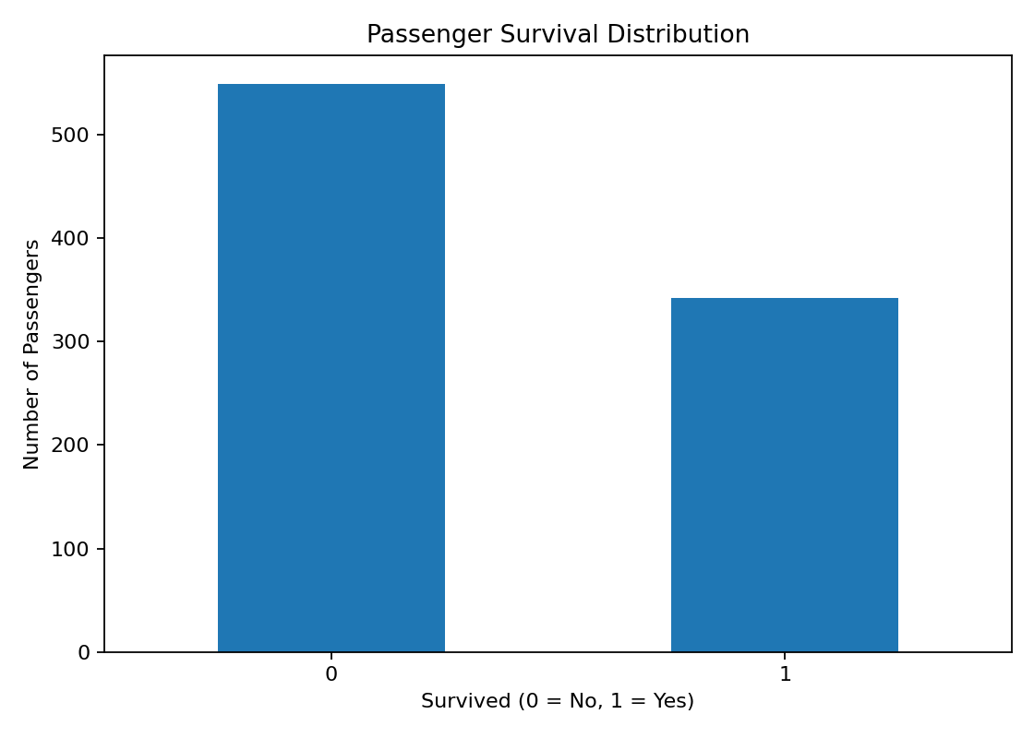
Figure 1. Titanic – Passenger Survival Distribution
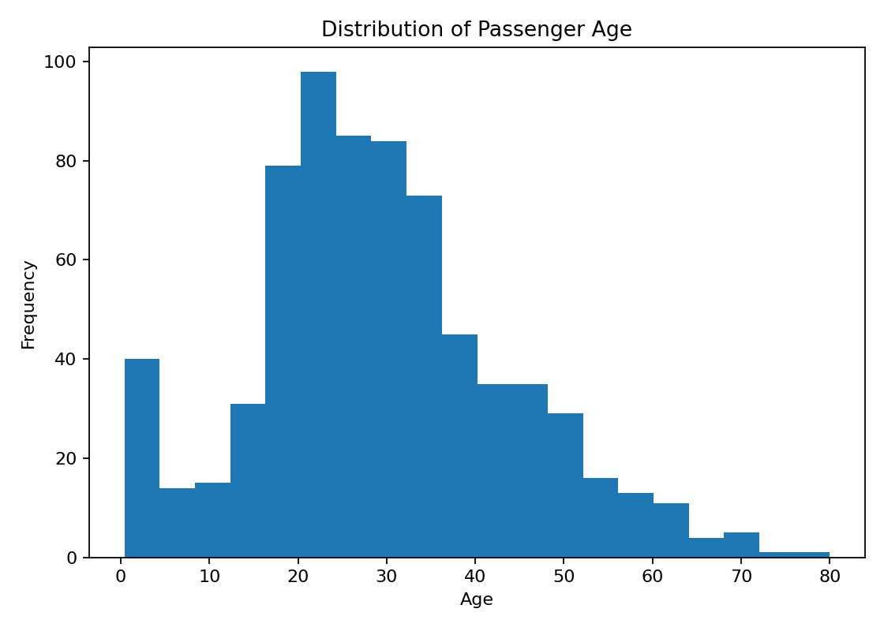
Figure 2. Titanic – Passenger Age Distribution
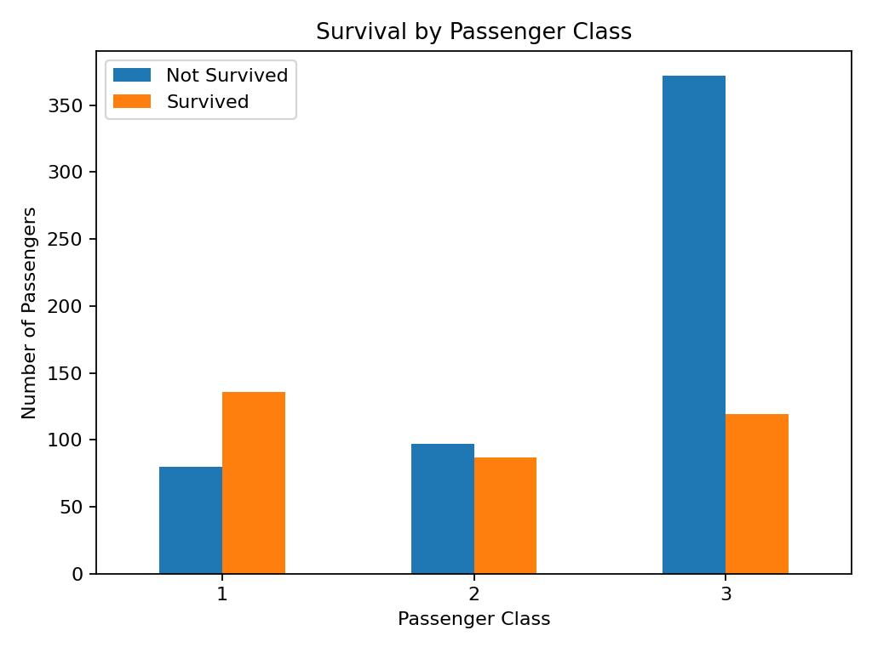
Figure 3. Titanic – Survival by Passenger Class
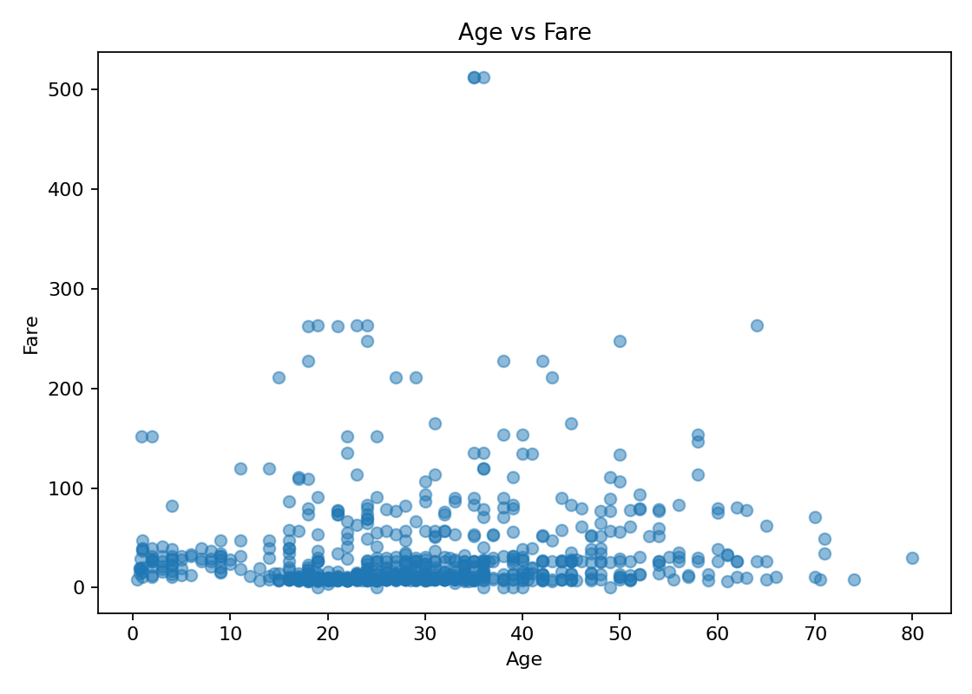
Figure 4. Titanic – Age vs Fare

6. Week 2 – COVID-19 Advanced Visualization and Storytelling
The project used seven visualizations to move from population description to clinical severity. Each chart was designed to add a distinct layer rather than repeat the same information.
- Age distribution establishes the demographic foundation.
- Age groups make comparisons easier for a non-technical audience.
- ICU status across age groups connects demographics to a severity indicator and should be interpreted as association.
- Pneumonia status shifts the story toward clinical condition.
- The risk-factor heatmap summarizes relationships among multiple risk factors.
- Sex distribution adds a second demographic dimension.
- Intubation versus ICU completes the severity-focused comparison.
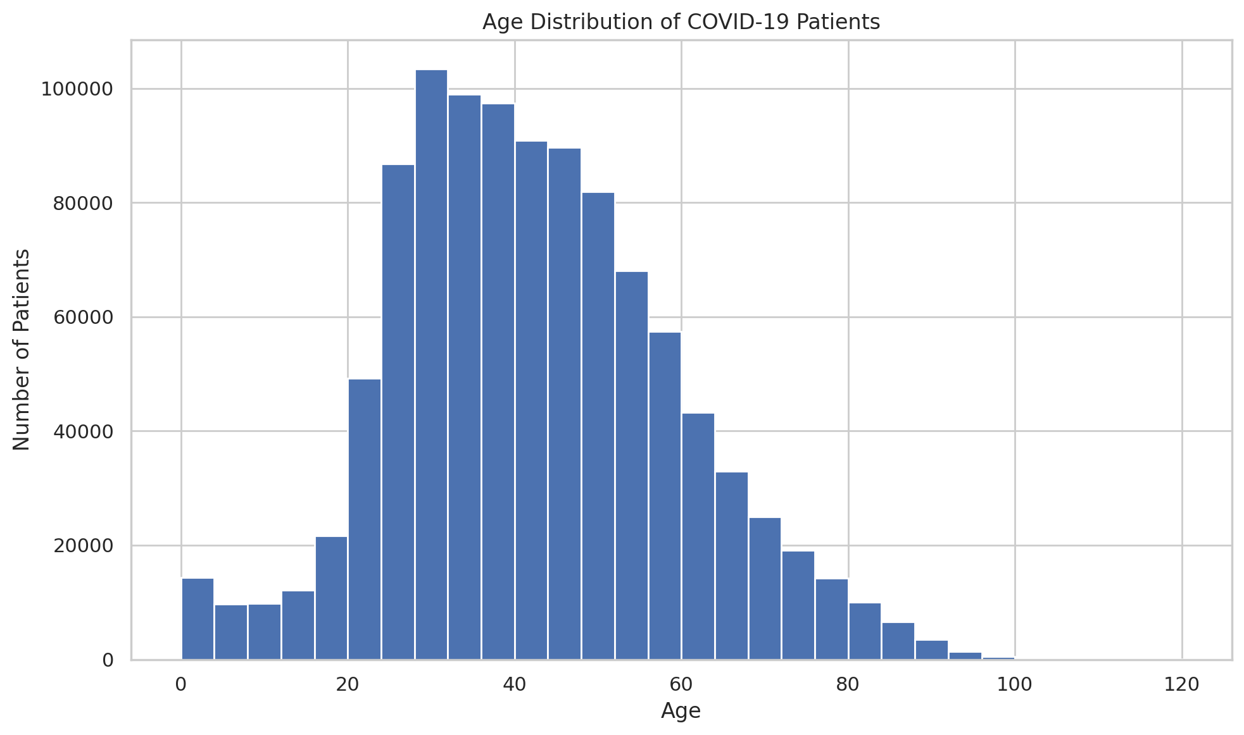
Figure 5. COVID-19 – Age Distribution
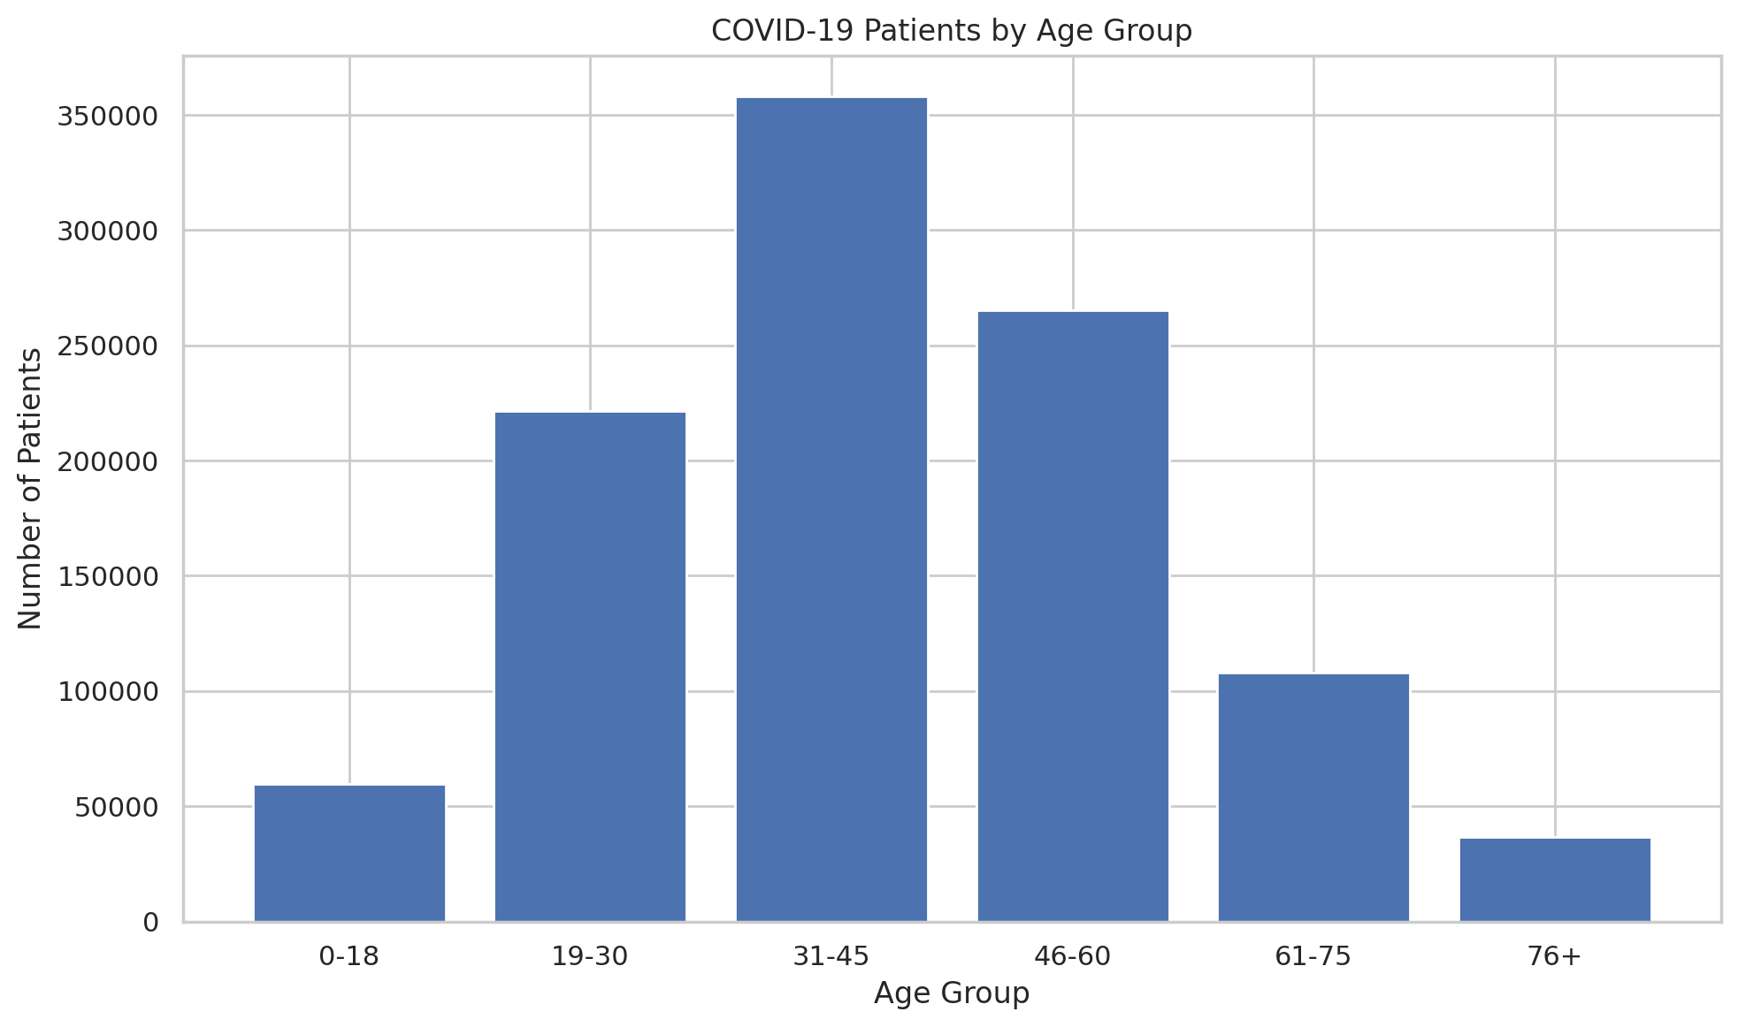
Figure 6. COVID-19 – Age Groups
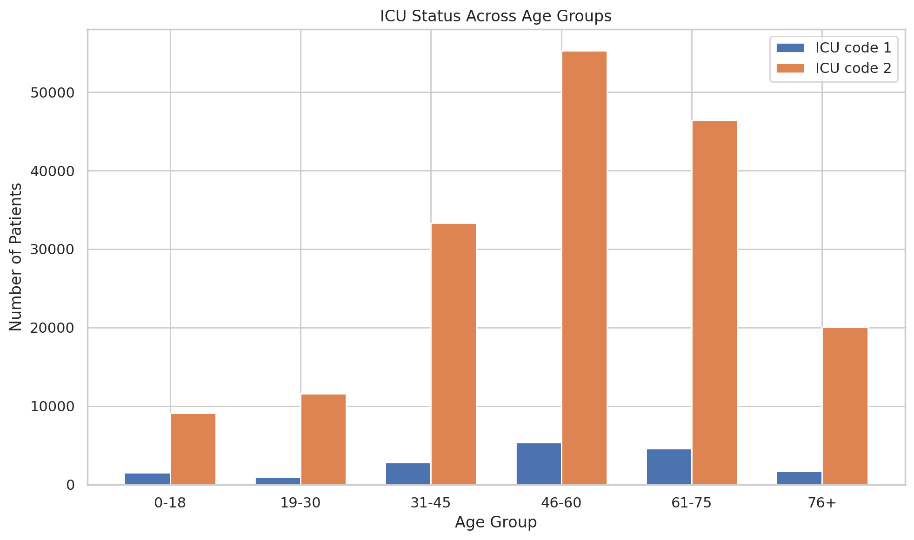
Figure 7. COVID-19 – ICU Status Across Age Groups
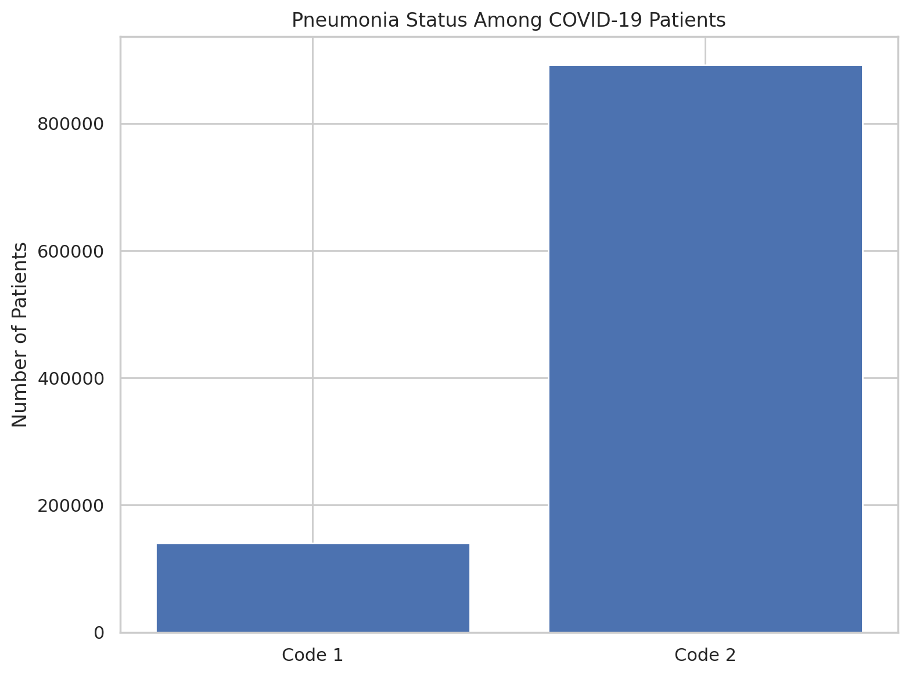
Figure 8. COVID-19 – Pneumonia Status
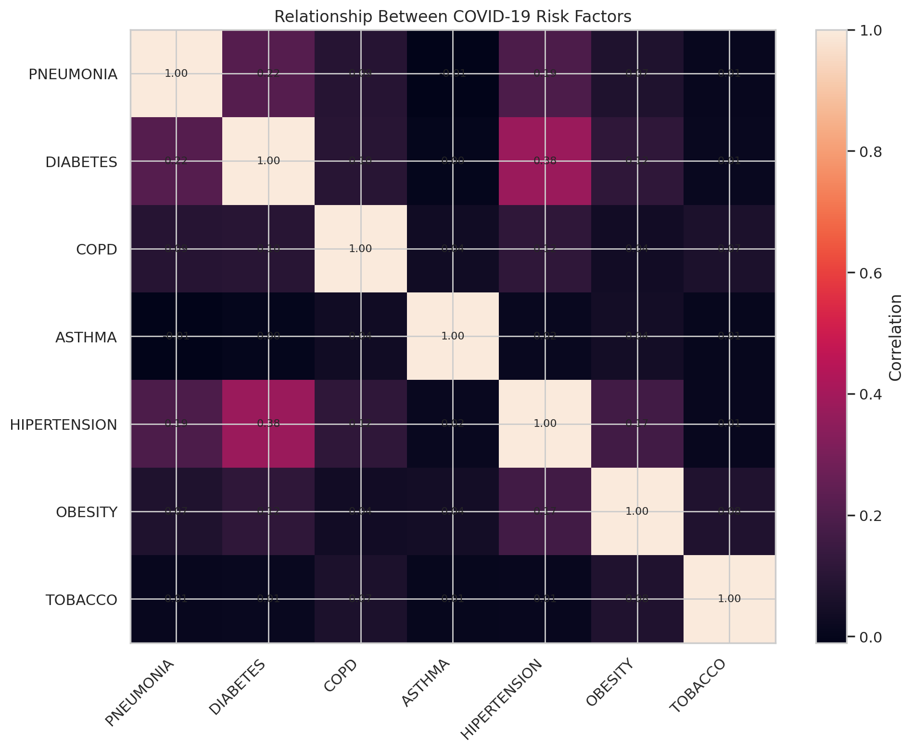
Figure 9. COVID-19 – Risk Factor Heatmap
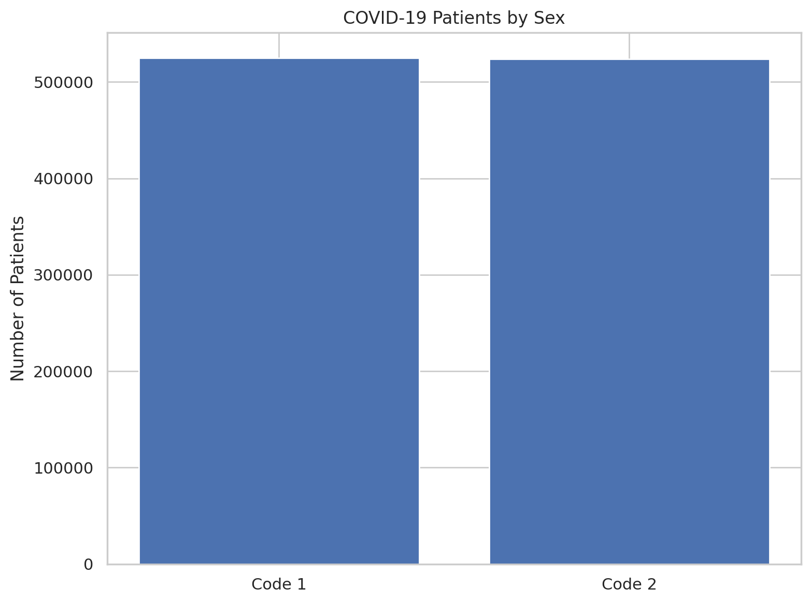
Figure 10. COVID-19 – Sex Distribution
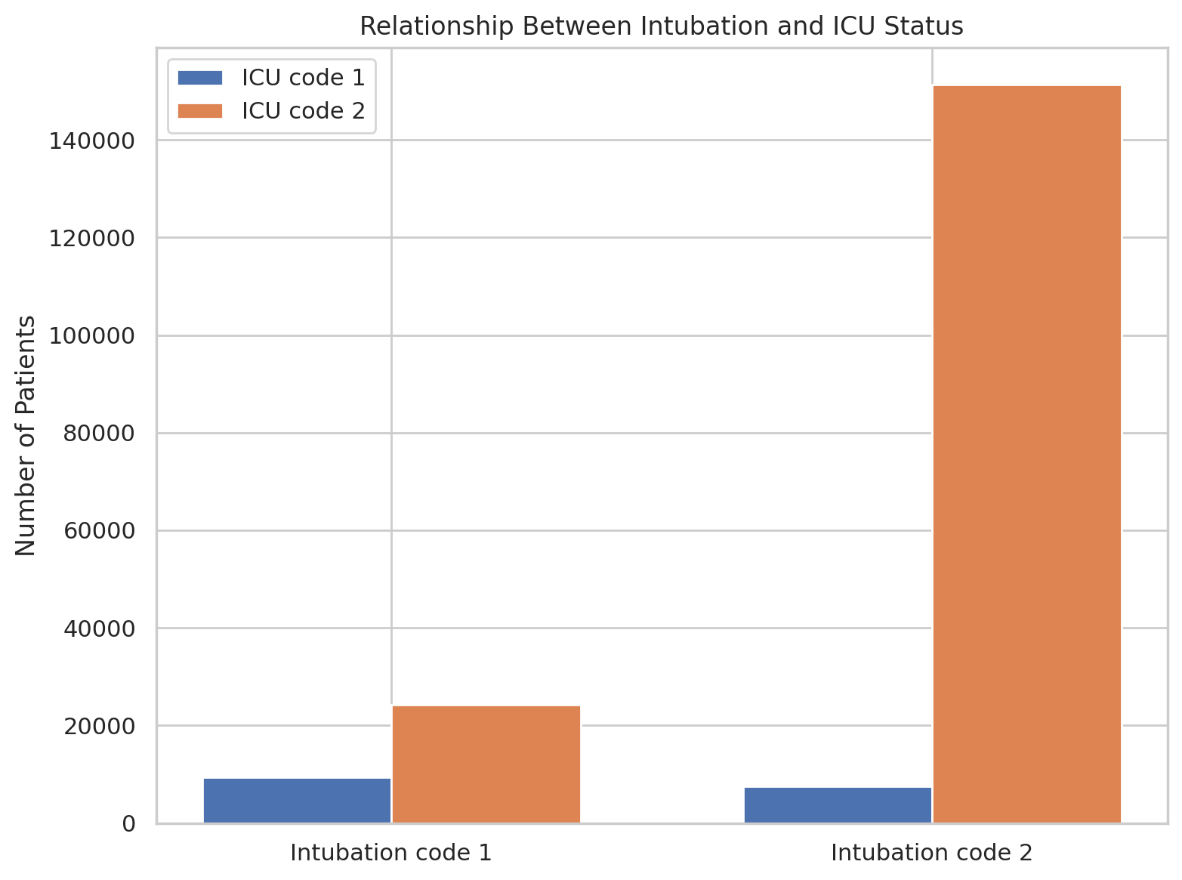
Figure 11. COVID-19 – Intubation vs ICU
Practical implication: similar visual analysis can support healthcare resource-planning discussions and help researchers identify patterns for further investigation. The source report stresses that the dataset is observational and should not be used to make causal claims without an appropriate design.

7. Week 3 – Statistical Analysis and Hypothesis Testing

7.1 Research Question
Is there a statistically significant difference in the average Math Scores of students who completed test preparation and those who did not?

7.2 Hypotheses
H₀: There is no statistically significant difference in mean Math Scores between the two test-preparation groups.
H₁: There is a statistically significant difference in mean Math Scores between the two test-preparation groups.

7.3 Descriptive Results
Group | N | Mean | Std. Dev.
completed | 10,573 | 69.76 | 14.95
none | 20,068 | 65.16 | 15.10

7.4 Hypothesis Test Results
- Welch t-statistic = 25.5092
- p-value = 1.89495e-141
- Mean difference (completed − none) = 4.5991 points
- 95% confidence interval = [4.2457, 4.9525]
- Cohen's d = 0.3056
Because the p-value is far below α = 0.05, the null hypothesis is rejected. The dataset provides statistically significant evidence of a difference in average Math Scores. The source report correctly limits the conclusion to an association and does not claim that test preparation alone caused the difference.
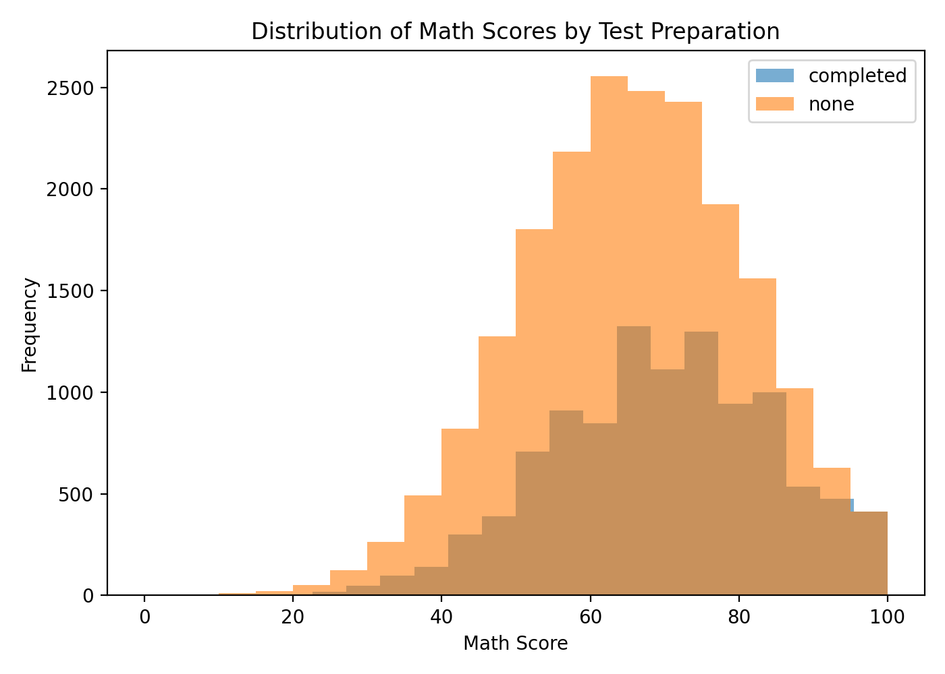
Figure 12. Week 3 – Histogram of Math Scores
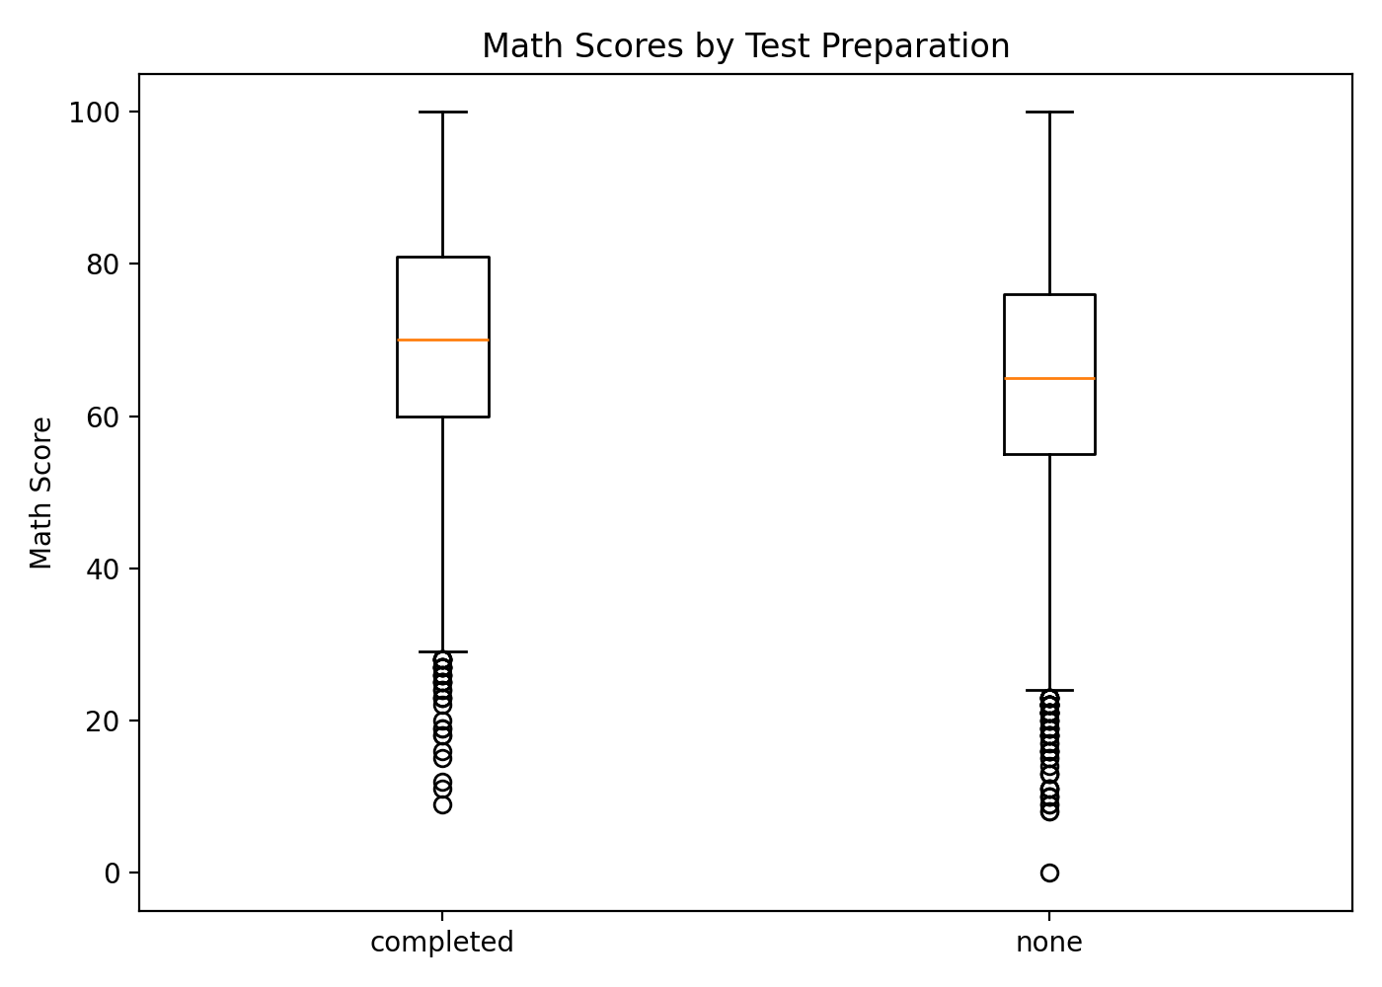
Figure 13. Week 3 – Boxplot of Math Scores

8. Week 4 – Machine Learning Model Development and Evaluation

8.1 Dataset and Preprocessing
The Iris dataset contains 150 observations, four numerical input features and one categorical target with three balanced classes: Setosa, Versicolor and Virginica. No missing values were present.

8.2 Model and Evaluation
Metric | Result
Training Accuracy | 95.83%
Testing Accuracy | 93.33%
Precision | 93.33%
Recall | 93.33%
F1-Score | 93.33%
Weighted ROC-AUC | 99.67%
Incorrect Predictions | 2 / 30

8.3 Error Analysis
All 10 Setosa test observations were classified correctly. One Versicolor was classified as Virginica and one Virginica as Versicolor. The source report attributes these errors to greater similarity and overlap in measurements between those two classes.

8.4 Generalization
Training accuracy was 95.83% and testing accuracy 93.33%, a 2.50 percentage-point gap. The small gap suggests good generalization and no strong evidence of overfitting in this experiment.
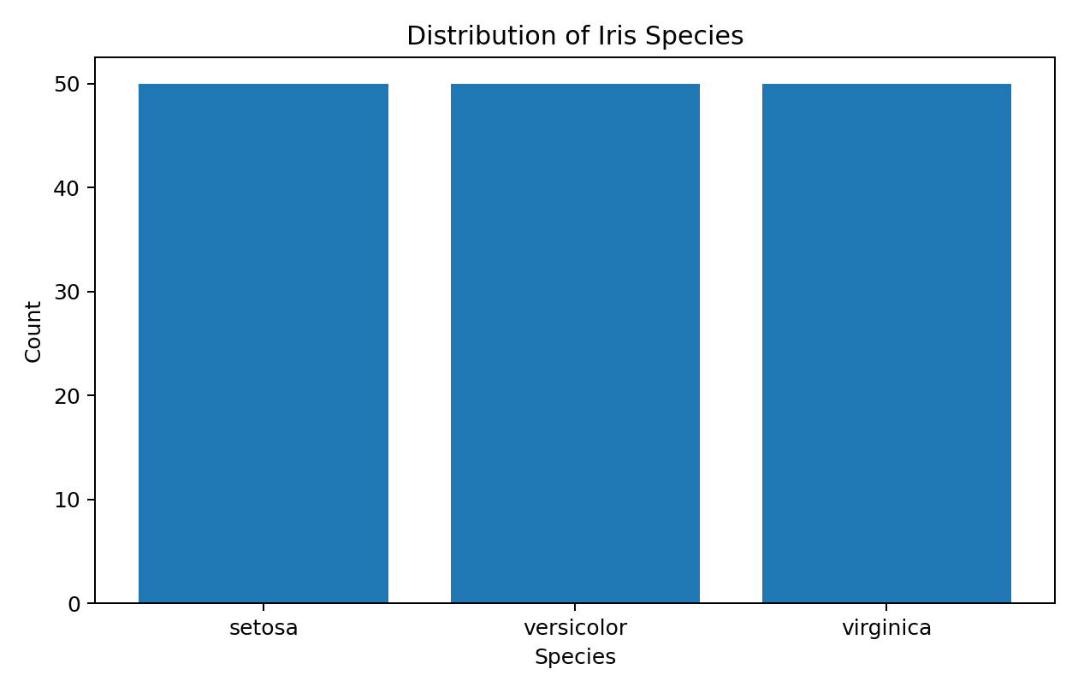
Figure 14. Week 4 – Distribution of Iris Species
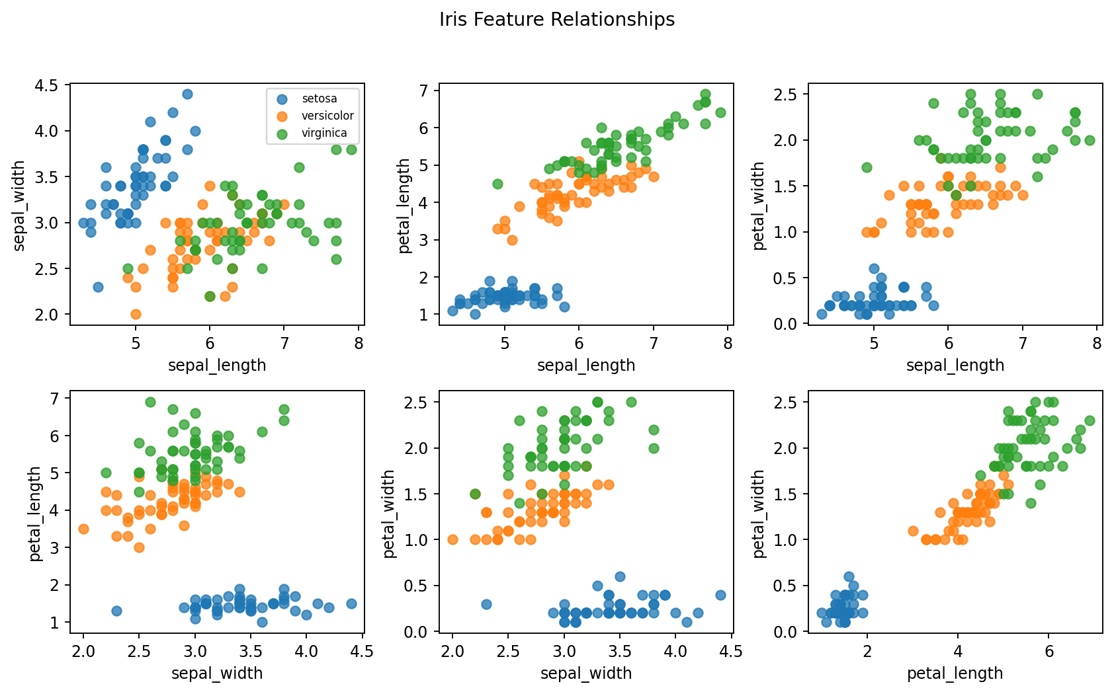
Figure 15. Week 4 – Iris Feature Relationships
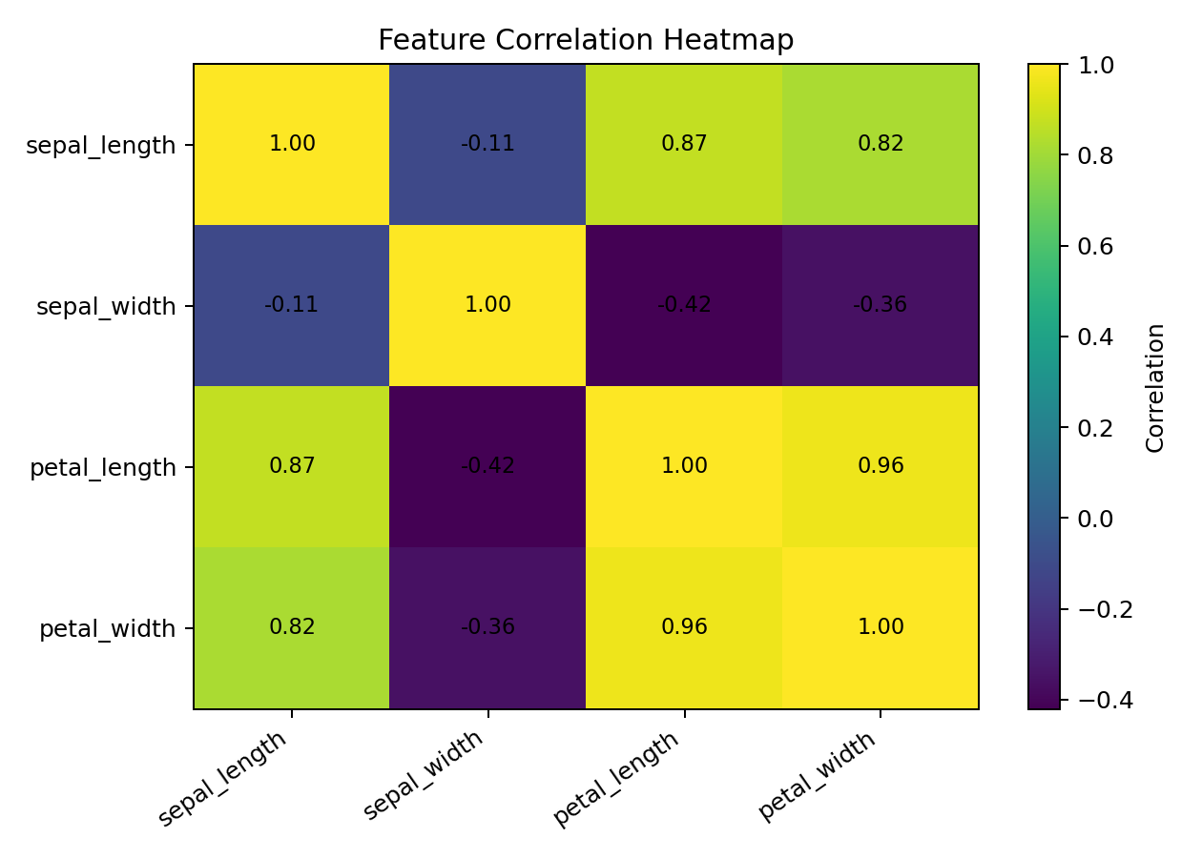
Figure 16. Week 4 – Feature Correlation Heatmap
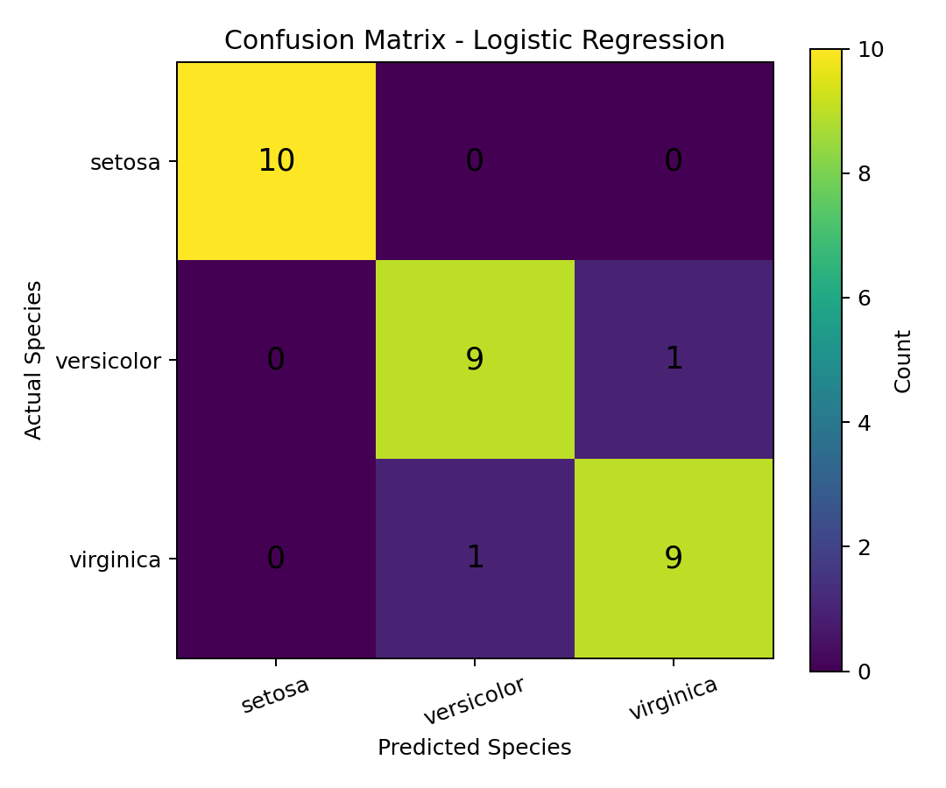
Figure 17. Week 4 – Confusion Matrix
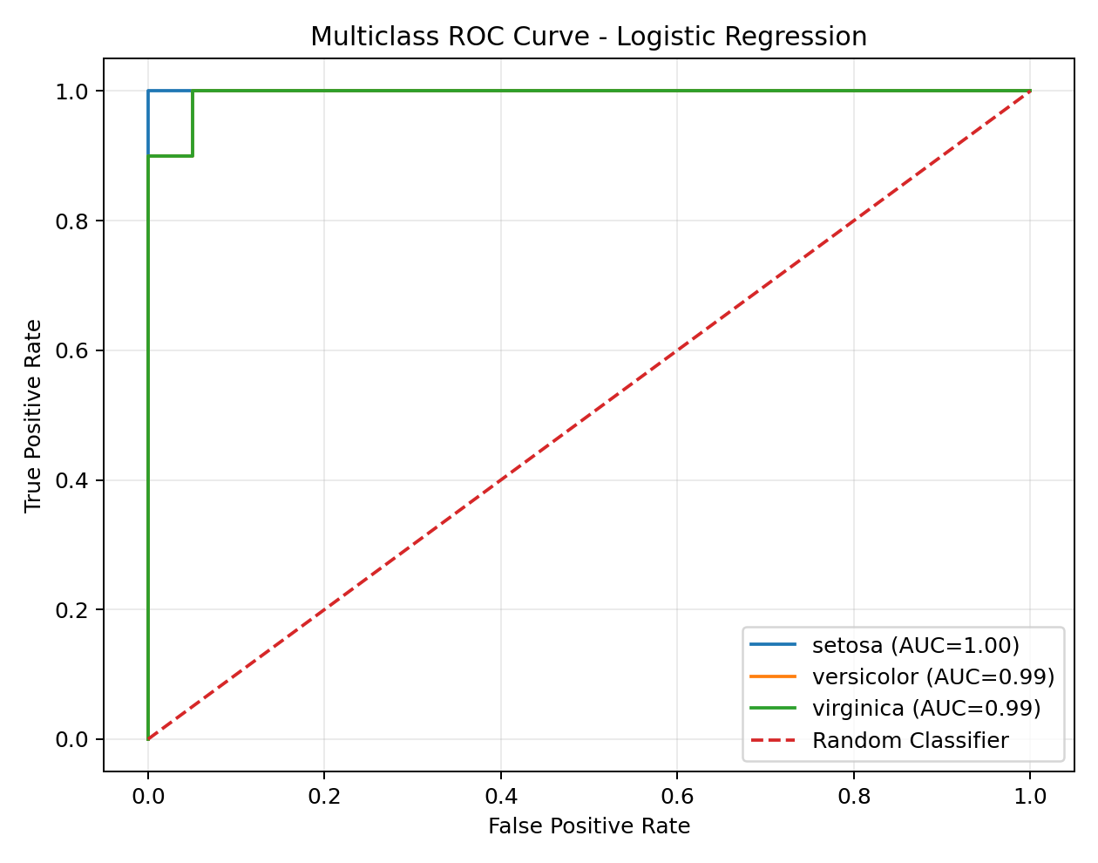
Figure 18. Week 4 – Multiclass ROC Curve
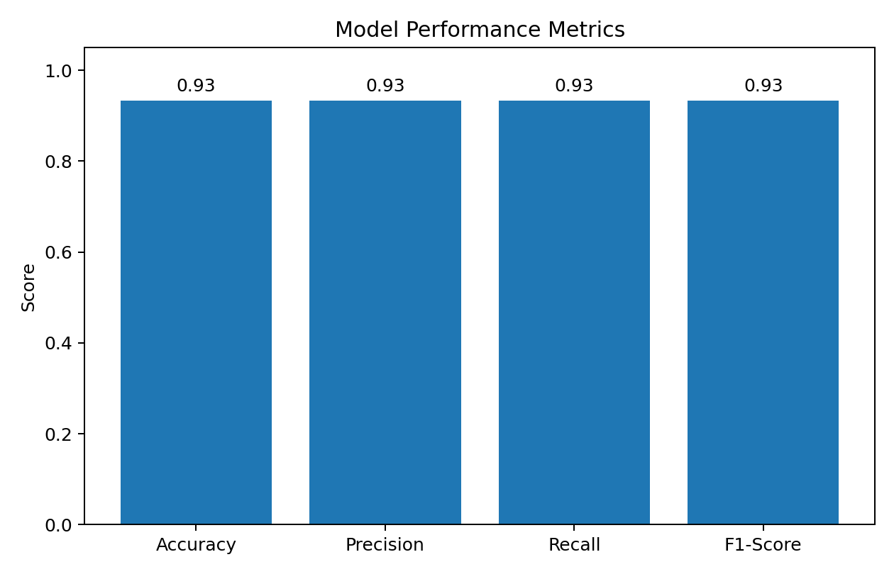
Figure 19. Week 4 – Model Performance Metrics
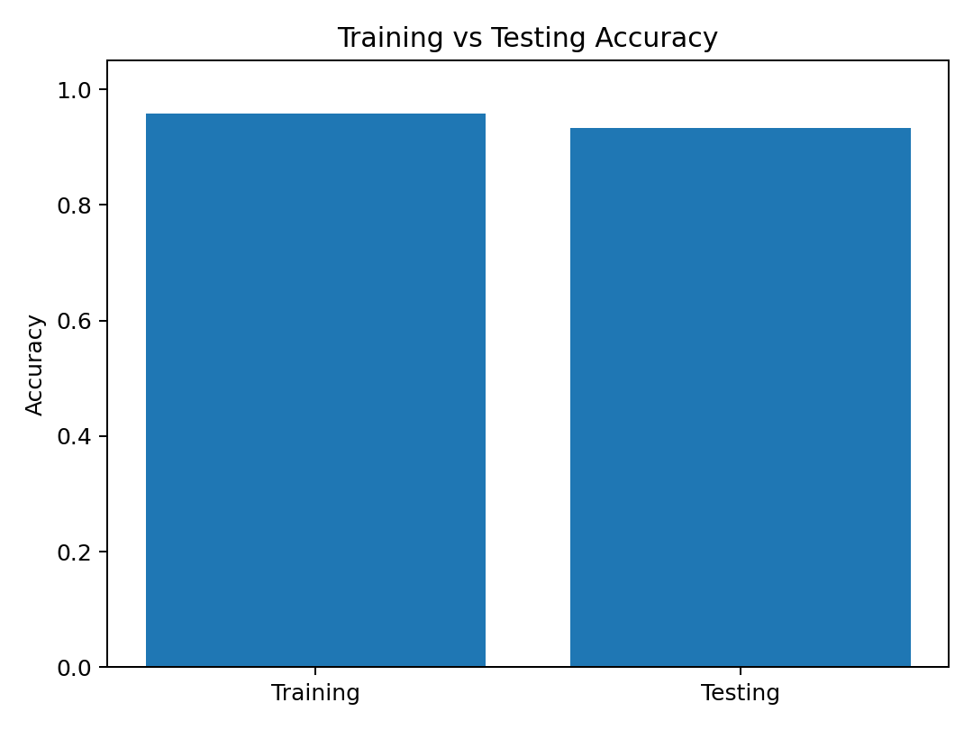
Figure 20. Week 4 – Training vs Testing Accuracy

9. Cross-Project Synthesis
The four projects collectively show a progression from descriptive analytics to inferential and predictive analytics.

Data quality before interpretation
Titanic and COVID-19 work demonstrate that missing and coded values must be identified and handled explicitly.

Visualization as analytical reasoning
The portfolio uses charts not only for presentation but to reveal distributions, group differences, relationships and severity patterns.

Inference adds statistical discipline
The Week 3 t-test quantifies uncertainty and provides a confidence interval rather than relying only on visual differences.

Prediction requires validation
The Week 4 model separates training and testing data, uses standardization correctly, and reports multiple evaluation metrics.

Interpretation must respect study design
Both Week 2 and Week 3 explicitly avoid causal claims from observational data.

Model errors are informative
The Week 4 confusion matrix identifies exactly where the classifier struggles, supporting targeted improvement.

10. Strategic Recommendations

1. Establish a standardized data-quality checklist
Before analysis, validate missing values, duplicate records, categorical codes, data types and variable definitions. This reduces downstream analytical risk.

2. Move from descriptive analysis to validated inference
Where exploratory patterns are important, use appropriate hypothesis tests, confidence intervals and effect sizes rather than relying only on charts.

3. Prioritize meaningful segmentation
For Titanic-style analysis, passenger class is a clear candidate for subgroup investigation. For clinical datasets, demographic and risk-factor segments can help identify patterns for research and resource planning.

4. Use stakeholder-oriented visual storytelling
Arrange dashboards and reports as population → characteristics → risk factors → outcomes/interventions. This makes complex analysis easier to interpret.

5. Distinguish statistical significance from practical significance
The Week 3 result is highly statistically significant, but Cohen's d of 0.3056 should also be considered when assessing the practical magnitude of the difference.

6. Benchmark machine-learning models
Use Logistic Regression as a transparent baseline, then compare Decision Tree, KNN, SVM and Random Forest with cross-validation and hyperparameter tuning.

7. Investigate model errors
The Iris errors are concentrated between Versicolor and Virginica. Future modeling should examine feature importance, class boundaries and alternative algorithms.

8. Preserve reproducibility
Maintain notebooks/scripts, preprocessing rules, dataset definitions, figures and evaluation outputs together with a README and clear project structure.

9. Use cautious language for observational datasets
Use 'associated with' or 'pattern observed' unless a causal design supports stronger claims. This is especially important for healthcare and educational data.

11. Potential Business and Research Impact

11.1 Business / Operational Impact
The portfolio demonstrates methods that can improve reporting quality, data-driven segmentation and decision support. Standardized data preparation can reduce inconsistent outputs; visual storytelling can improve stakeholder understanding; and predictive modeling can support automated classification when validated on representative data.

11.2 Research Impact
The analyses provide starting points for deeper research: survival prediction for Titanic, multivariable investigation of COVID-19 risk patterns, replication and subgroup analysis of the student-performance hypothesis, and algorithm benchmarking for Iris classification.

11.3 Decision-Making Value
A key value of the portfolio is methodological: decisions should be tied to measurable evidence, uncertainty should be reported, and limitations should be visible. This reduces the chance that stakeholders act on an attractive visualization or high model score without understanding context.

12. Limitations
- The Week 5 synthesis is based on the four uploaded Week 1–4 reports; no additional source artifacts were provided.
- The Titanic analysis is primarily exploratory and does not contain a completed predictive model.
- The COVID-19 dataset is observational and includes coded unknown values; clinical interpretation requires the original codebook.
- The student-performance comparison is observational, so the significant difference does not establish that test preparation caused the score difference.
- Other factors such as parental education, lunch type and study habits may influence student scores.
- The Iris dataset is small and clean relative to many real-world datasets, so its high performance should not be generalized automatically.
- Logistic Regression may not capture complex nonlinear relationships, and Versicolor/Virginica measurements overlap.
- The supplied Week 2 report indicates that the original public dataset URL should be added, but the URL itself was not present in the uploaded report.

13. Future Work
- Integrate additional internship artifacts if available.
- Perform statistical hypothesis testing on key Titanic relationships.
- Build and compare Titanic survival classification models.
- Use multivariable methods for COVID-19 severity analysis after validating clinical variable definitions.
- Replicate the Week 3 test with additional controls or stratification where the data permit.
- Compare Logistic Regression with KNN, SVM, Decision Tree and Random Forest using cross-validation.
- Apply feature selection/engineering and hyperparameter tuning.
- Validate predictive results on larger or independent datasets where possible.
- Develop an interactive dashboard and reproducible GitHub project structure.

14. Workload Alignment (30–35 Hours)
The Week 3 source report specifies a 35-hour plan: hypothesis formulation 3h, dataset understanding 4h, cleaning 4h, EDA 4h, statistical testing 6h, Python coding 4h, visualization 3h, interpretation 3h and report preparation 4h. The Week 5 synthesis consolidates outputs from Weeks 1–4 into the required comprehensive reporting format.
Activity | Planned Hours
Topic & hypothesis formulation | 3
Dataset understanding & collection | 4
Data cleaning & preparation | 4
Exploratory data analysis | 4
Statistical testing | 6
Python coding | 4
Visualization | 3
Interpretation & conclusion | 3
Report preparation | 4
Total | 35

15. Conclusion
The Week 5 portfolio demonstrates a coherent progression through core data-science competencies. Week 1 establishes reliable data preparation and exploratory analysis. Week 2 demonstrates advanced visual communication of a large clinical dataset. Week 3 adds formal statistical inference, showing a statistically significant 4.60-point difference in mathematics scores between the two test-preparation groups while appropriately avoiding causal claims. Week 4 demonstrates predictive modeling with Logistic Regression, achieving 93.33% testing accuracy and 99.67% weighted ROC-AUC on the Iris dataset.
The combined lesson is that strong data science is not defined by a single chart, p-value or accuracy score. It requires a disciplined pipeline: clean data, appropriate methods, transparent evaluation, careful interpretation and recommendations that match the evidence. The next stage is to extend the portfolio with stronger validation, model comparison, reproducibility and real-world datasets.

16. References
- Titanic dataset and Week 1 internship report supplied for the project.
- COVID-19 clinical dataset and Week 2 visualization report supplied for the project.
- Student performance dataset and Week 3 hypothesis-testing report supplied for the project.
- Iris dataset and Week 4 machine-learning report supplied for the project.
- Python, Pandas, NumPy, Matplotlib, Seaborn, SciPy and Scikit-learn documentation as referenced in the weekly reports.

17. Appendix – Representative Code Snippets
import pandas as pd
df = pd.read_csv("Titanic-Dataset.csv")
print(df.head())
print(df.shape)
print(df.info())
Week 1: loading and inspecting the Titanic dataset.
df['Age'] = df['Age'].fillna(df['Age'].median())
df['Embarked'] = df['Embarked'].fillna(df['Embarked'].mode()[0])
df = df.drop(columns=['Cabin'])
df = df.drop_duplicates()
Week 1: documented preprocessing steps.
df["MathScore"] = pd.to_numeric(df["MathScore"], errors="coerce")
group1 = df[df["TestPrep"] == "completed"]["MathScore"].dropna()
group2 = df[df["TestPrep"] == "none"]["MathScore"].dropna()
t_stat, p_value = stats.ttest_ind(group1, group2, equal_var=False)
Week 3: Welch independent-samples t-test.
X_train, X_test, y_train, y_test = train_test_split(
X, y, test_size=0.20, random_state=42, stratify=y
)
scaler = StandardScaler()
X_train_scaled = scaler.fit_transform(X_train)
X_test_scaled = scaler.transform(X_test)
model = LogisticRegression(max_iter=1000, random_state=42)
model.fit(X_train_scaled, y_train)
Week 4: stratified split, standardization and Logistic Regression training.

18. Final Submission Checklist
☐ Executive Summary completed
☐ Introduction, objectives and methodology included
☐ Weeks 1–4 findings integrated
☐ Visualizations and descriptive annotations included
☐ Statistical results and model metrics included
☐ Representative code snippets included
☐ Strategic recommendations linked to findings
☐ Business/research impact discussed
☐ Limitations and future work included
☐ 30–35 hour workload alignment documented
☐ Word document prepared in .docx format
Report Submission Description
This Week 5 final report presents a consolidated overview of the data science work completed across Weeks 1 to 4 of the internship. The report brings together the complete analytical journey, starting with data acquisition, cleaning, exploratory data analysis, visualization and storytelling, followed by statistical hypothesis testing and machine learning model development and evaluation. In Week 1, the Titanic dataset was examined through data-quality checks, missing-value treatment, exploratory analysis and visualization to understand passenger survival patterns. Week 2 expanded the visualization work to a large COVID-19 patient dataset, using demographic and clinical variables to communicate patterns related to patient characteristics, risk factors and severity indicators. Week 3 applied statistical inference to investigate whether completion of test preparation was associated with a significant difference in mathematics scores, using descriptive statistics and Welch's independent-samples t-test. Week 4 progressed to supervised machine learning through an Iris flower classification project using Logistic Regression, standardized features and a stratified train-test split, followed by evaluation using accuracy, precision, recall, F1-score, ROC-AUC and confusion-matrix analysis. Together, these projects demonstrate practical skills in Python, Pandas, NumPy, Matplotlib, Seaborn and scikit-learn, as well as the ability to interpret analytical results rather than relying only on numerical outputs. The report also identifies cross-project lessons, limitations, reproducibility practices and future improvements such as stronger validation, model benchmarking, feature engineering and deeper statistical analysis. The associated GitHub repositories provide the technical project trail and support reproducibility and review of the implemented work. Overall, this final report demonstrates a progression from foundational data preparation and visual analysis to statistical reasoning and predictive machine learning, while emphasizing responsible interpretation, clear communication and practical application of data science methods.
GitHub Project Repositories
- Titanic Data Analysis
- COVID-19 Patient Outcomes – Advanced Data Visualization and Storytelling
- Statistical Analysis & Hypothesis Testing
- Machine Learning – Iris Classification
Submission note: Replace the blank Student Name, Internship/Organization and Submission Date fields on the title page before submission, if required by the internship guidelines.

